De luna apartments [Guesthouse]
Founder: Zengele Family

Student number | ST10505979
Module code | WEDE5020
Module name | Web Development
lecturer | Rohan Maharaj
Date of submission | 1 September 2026
Presentation by | Thandeka Zengele

Table of Contents
Organised overview 3
2. Website goals and objectives 3
2.1 Specific Goals: 3
2.2 Key performances indicators 3
3. Current Website Analysis 3
4. Proposed Website Feature and functionality 4
5. Design and User Experience 5
5.1 Design 5
5.2 User Experience 5
6. Technical requirements 6
7. Timeline and Milestones 6
8. Budget 6
9. References 7

Organised overview
- Name: De Luna Apartments [Guesthouse]

- Brief History: De luna apartments were created by the Zengele family. It is a self-catering accommodation in Bethlehem, Free State. The owners saw a good business opportunity it would be for their family. They saw potential in their home and created something great. De luna apartments want to provide comfortable accommodation for business travellers, couples, families and holiday guests that are visiting the region that they live in.

- Our vision & mission: Their goal is to make every stay feel like a home while delivering exceptional hospitality to all. They want de luna apartments to grow in the hospitality sector and make De Luna apartments one of the best accommodations in Bethlehem.

- Target Audience: people who are travelling for work, couples, tourists traveling along the Clarens /Golden Gate Highlands route and families.

2. Website goals and objectives

2.1 Specific Goals:
- Have a professional clear-booking platform to eliminate commission fees from third party travel agencies
- Have a professional platform where people can enquire about their accommodation without customers going being confused on where to contact them
- Have a platform where de luna apartments can showcase their full room specifications, comfort amenities and available add on services
- Have a platform where people can rate their services and accommodation
- Have customers book and pay for the accommodation on the websites and prevent informal payments

2.2 Key performances indicators
- Website growth: Tack monthly visitors, especially from visitors from other provinces and countries.
- Inquiry submissions: Tack the total number inquires
- Speed: the website should be fast so that the bounce rates don’t increase

3. Current Website Analysis
- The current business does not have a website and the disadvantages of it can affect their business badly. They might be losing new customers without even knowing. It can limit their business growth, lose credibility, trust and it also send red flags to customers when their business doesn’t have a website because normally when people are not sure of something they normally go search about it and find out more information about the accommodation to check if it’s legit or not. The lack of not having a website can make it harder for people to take the business seriously which instils doubt from potential customers and leaves a bad mark on their business. (AISO,2025)

4. Proposed Website Feature and functionality
- Home page: the home page will present images showcasing the guest house. It will have a hero section that will display the logo of the guesthouse, about us, contact us, book now, inquire, apartment, nearby attractions and reviews.

- About us: In this section there will be where the story behind the guesthouse will be shown telling the customer more information about the guesthouse

- Apartments: the apartment pages will show all the amenities and pictures of how the apartment looks inside. The business currently has one bedroom, lounge, a bathroom, indoor fireplace, and a kitchen.

- Book Now: The Book Now will be displayed as a button where there the customer will press to make their booking. It will allow customers to select their dates, number of guests, and pay online [optional].

- Contact us: This section will include the business’s phone number, email address, google maps, contact form and WhatsApp. Having these on the website will make it easy for the customer to contact the business owners.

- Inquire: Here the customers will be able to send an enquiry to the business about their services.

- Nearby Attractions: In this section the website will display all the amazing attractions nearby the guesthouse that guest might want to explore while they are staying in the accommodation.

- Reviews: This section allows customers to rate their experience at the accommodation and the service they got.

- FAQ: Here the business will display frequently/common asked questions that guest might want to ask and the answers to the questions will be provided beforehand.

- Functionality: the website will have features like fast loading responsive design, dynamic photo sliders , social media video embeds and direct WhatsApp messaging integration.

5. Design and User Experience

5.1 Design
- Colour scheme:







(ColorHexa,2026)

- Typography:

Headings – Times new Roman
Subheadings – Arial
Body Text – Calibari

- Layout and Design:

The website should have a multi layered screens

5.2 User Experience
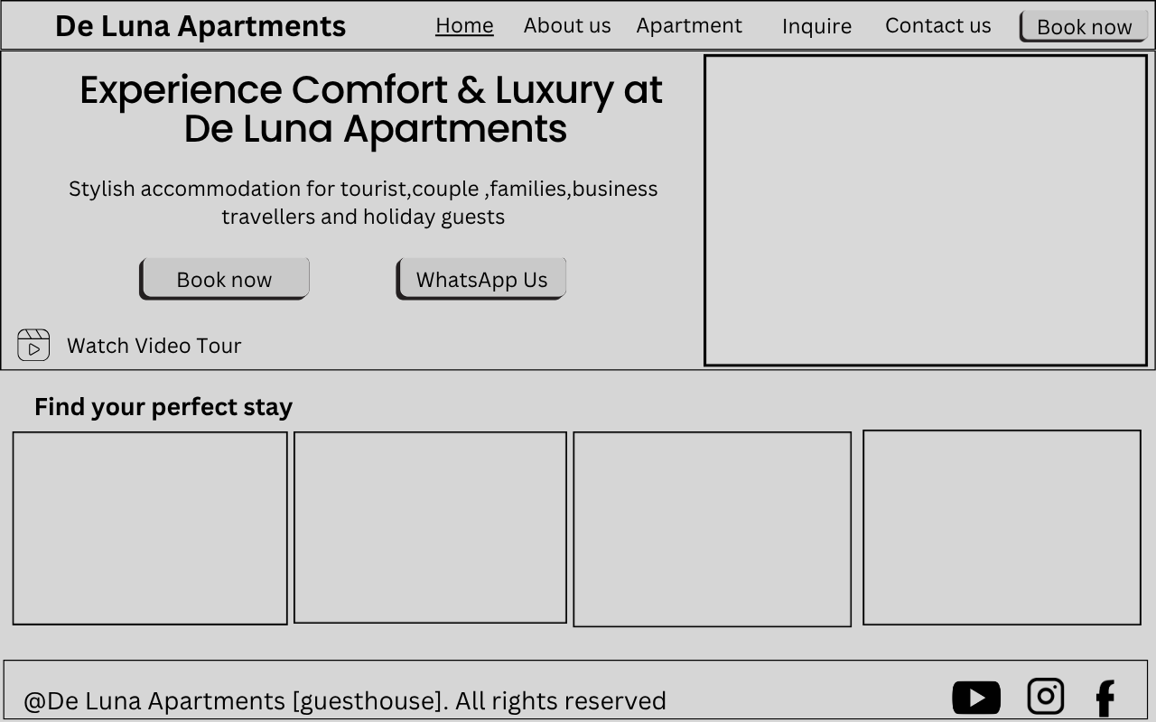



6. Technical requirements
- Domain Name: .co.za domain registration tailored for local south affrication optimization
- Hosting services: This website’s hosting platform will Hostinger
- Core languages: The structure of the website, I will be using HTML. Then CSS will be used for the styling of the website and JavaScript for the booking, calculator, interactive sliders and DOM manipulation.

7. Timeline and Milestones
Milestones | Tasks | Timeline
Planning & Proposal | Research, Proposal and lecture approval | WEEK 1-2
UI Design & Wireframe | Creating High fidelity prototypes, visual preparation and layout approvals | WEEK 2-4
Frontend Development | Structure pages with HTML  Use CSS to style the pages  Use JavaScript for the logic of the website | WEEK 4-7
Testing & Optimization | Check it works on devices  Layout adjustments  Check the performance of the website | WEEK 7-10
Documentation & Final PoE | Technical documentation  Doing the README file  Submit the completed PoE | WEEK 10 - 12

8. Budget
Cost Item | Description | Cost
Domain Registration | Registration of custom | R 361.00 Annual
UI/UX Design and Prototype | Figma prototype and wireframe | R 304.00 Monthly
Website Development | Custom frontend design with interactive booking widgets | R 10,000.00 Once-off
Web Hosting | Web hosting with South African servers including SSL certificate | R 29.00 Monthly
Maintenance and Security | Security updates, content updates and regular back ups | R 1,500.00 Monthly
Estimated Cost |  | R 12,194.00

9. References
AISO,2025. Critical Risks of Not Having Website That Undermine Your Business Success. AISO. Available at: https://aisqbusiness.com/risks-of-not-having-website/ [Accessed on 17 August 2026]
Canva,2013. Website wireframes. Canva. Available at https://canva.link/71rdtf8r4nh9g7d [ Accessed on 17 August]
ColorHexa,2026. #0B1D3A Color information. ColorHexa. Available at: https://www.colorhexa.com/0b1d3a.png [Accessed on 17 August 2026]
ColorHexa,2026. #C9A227 Color information. ColorHexa. Available at: https://www.colorhexa.com/c9a227.png [Accessed on 17 August 2026]
ColorHexa,2026. #E7DFD1 Color information. ColorHexa. Available at: https://www.colorhexa.com/e7dfd1.png [Accessed on 17 August 2026]
ColorHexa,2026. #F2F2F2 Color information. ColorHexa. Available at: https://www.colorhexa.com/f2f2f2.png [Accessed on 17 August 2026]
ColorHexa,2026. #FFFFFF Color information. ColorHexa. Available at: https://www.colorhexa.com/ffffff.png [Accessed on 17 August 2026]
Digital Consulting,2026. Hacked website? We’ll clean it and get you back online. Digital Consulting. Available at :https://digitalconsulting.co.za/website-hack-fix-and-malware-removal-services/?gad_source=1&gad_campaignid=24056457740&gclid=CjwKCAjwwL_UBhAjEiwAEhuT5A6xQosBFm84s0_XRiT51cai12Er9yIKc2035ChJwzoURygHAWWvWhoCCOwQAvD_BwE [Accessed on 17 August 2026]
Field D and Wallace E, 2012.Figma. Available at: https://www.figma.com/pricing/ [Accessed on 17 August 2026]
Hostinger,2026. Plans & pricing. Hostinger. Available at: https://www.hostinger.com/pricing [Accessed on 17 August 2026]
GoDaddy,2026. Web hosting with a free domain. GoDaddy. Available at : https://www.godaddy.com/en-ph/offers/hosting?isc=zahosgon1&countryview=1&currencyType=ZAR&cdtl=c_698259157.g_1247947075625317.k_kwd-77997093068729:loc-168.a_.d_c.ctv_o&bnb=nb&msclkid=90f349446299136029f823d440721f35&utm_source=bing&utm_medium=cpc&utm_campaign=en-za_m365-ox_sem_py_nb_all-devices_aware-consider_x_pros_intl_broad_001&utm_term=buy%20domain%20with%20email&utm_content=%5Bemail-dom-buy%5D [Accessed on 17 August 2026]

Systrom K and Krieger M,2010. Da_Luna_Apartments_za. Tik tok. Available at: https://www.instagram.com/de_luna_apartments_za?igsh=MTdpYmN6ZDFkYTB4cA==[Accessed on 17 August 2026]
Yiming Z,2017. Da_Luna_Apartments_za. Instagram. Available at: https://www.tiktok.com/@da_luna_apartments_za?_r=1&_t=ZS-98aHNFSSlfg [Accessed on 17 August 2026]

